Group B
Experiment 6

Problem Definition:
File Transfer between Two Machines using UDP Sockets in Java

Objective
- To develop a Java program that transfers files (Script, Text, Audio, Video) from one machine to another using UDP sockets.
- To understand and demonstrate the working of connectionless communication in computer networks.
- To observe packet transfer behavior and reliability in UDP communication.

Tools & Software Required
- Java Development Kit (JDK 8 or above)
- Eclipse IDE for Java Developers (or any Java IDE)
- Sample files to transfer:
  - script.py (Python script)
  - notes.txt (Text file)
  - song.mp3 (Audio file)
  - video.mp4 (Video file)
- Two computers (or one computer with multiple terminals) connected via the network.

Theory
- UDP (User Datagram Protocol) is a connectionless protocol used in transport layer.
- Unlike TCP, UDP does not guarantee delivery or order of packets but is faster.
- UDP is suitable for applications like streaming, online gaming, or simple file transfer where speed is prioritized over reliability.
- In this program:
  - Server reads the file, splits it into packets, and sends them over UDP.
  - Client receives the packets and reconstructs the original file.

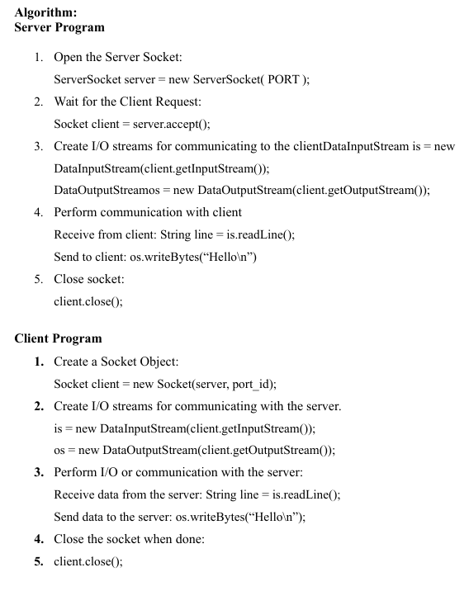

Program Description
- Server (UDPFileServer.java):
  - Reads the files to be sent.
  - Sends each file name to the client.
  - Sends file content in 1024-byte packets.
  - Sends an "EOF" signal after each file.
- Client (UDPFileClient.java):
  - Listens on a specific port (9876) for incoming packets.
  - Receives the file name and data.
  - Reconstructs and saves the file locally with prefix received_.
- Files transferred in this experiment:
  - Python Script (script.py)
  - Text File (notes.txt)
  - Audio File (song.mp3)
  - Video File (video.mp4)

Result
- The program successfully transfers multiple file types from server to client using UDP sockets.
- Files are received intact in the client project folder.
- Demonstrated the connectionless file transfer method.

Conclusion
Thus, we have successfully implemented UDP socket for file transfer between two machines.

